
University of Asia Pacific

Department of Computer Science & Engineering

COURSE TITLE : Data Communication and Computer
. Networks Lab
COURSE CODE : CSE 312
Report No : 01
Report title : Optical Fiber Communication System Using
NRZ Modulation
Date :

Submitted By : Submitted To :
Name : Md. Osman Goni Md. Al-Amin Sany
Reg. No : 23101040 Lecturer, Department of CSE
Section : A1 University Of Asia Pacific.

- Introduction
- Objectives
- To design and simulate an NRZ optical transmission link using external modulation (MZM).
- To analyze transmitted and received waveforms in time domain.
- To measure optical and electrical power at the transmitter and receiver.
- To observe the optical spectrum of the modulated signal using an OSA.
- To evaluate system performance using Eye Diagram, Q-factor, and BER.
- Component List
The system consists of the following components:
Transmitter
- Pseudo-Random Bit Sequence (PRBS) Generator (bit rate = 2e9 bits/s)
- NRZ Pulse Generator
- CW Laser Source (193.1 THz, power shown in the diagram)
- Mach–Zehnder Modulator (MZM)
- Oscilloscope Visualizer (Tx monitoring)
- Optical Power Meter (Tx)
- Optical Spectrum Analyzer (Tx)
- Optical Time Domain Visualizer (Tx)
Channel
- Optical Fiber (Length = 50 km)
Receiver
- PIN Photodetector
- Low Pass Bessel Filter (Cutoff frequency = 0.75 × bit rate)
- 3R Regenerator
- BER Analyzer
- Oscilloscope Visualizers (Rx monitoring)
- Electrical Power Meter Visualizers (Rx)
- Optical Power Meter (post-fiber / pre-PIN)
- Optical Spectrum Analyzer (post-modulation / post-link, as connected)
- Working Process
The system follows a standard optical communication pipeline:
Digital Source → Electrical Encoding → Optical Modulation → Fiber Transmission → Optical Detection → Signal Recovery → Performance Analysis
  - Overall Architecture
The system follows this chain:
PRBS → NRZ Pulse Shaping → MZM (with CW laser) → 50 km fiber → PIN detection → LPF (Bessel) → 3R regeneration → BER/Eye analysis
  - Transmitter Section
    - Pseudo-Random Bit Sequence (PRBS) Generator
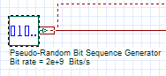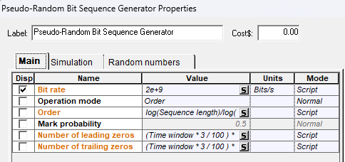
The PRBS generator produces a binary sequence (0s and 1s) that statistically resembles real data traffic. A PRBS is widely used for testing because it stresses the system with frequent transitions and random patterns. Here, Bit rate = 2 × 10⁹ bits/s
Observed output:
- A digital bit stream with logic levels representing bits.
    - NRZ Pulse Generator
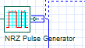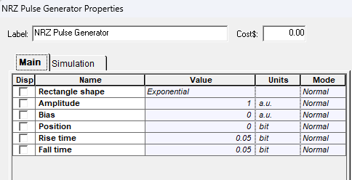
The NRZ pulse generator converts the binary sequence into an NRZ electrical waveform. In NRZ signaling:
- Bit “1” stays high for the entire bit period.
- Bit “0” stays low for the entire bit period. This is a bandwidth-efficient and common baseband line coding format.
Observed output:
- A rectangular electrical waveform with bit duration (T_b = 1/R_bs).
    - CW Laser Source
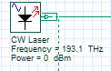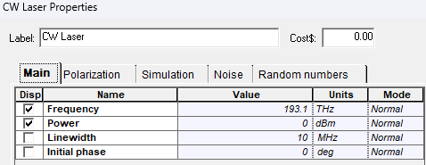
The CW laser acts as the optical carrier source for transmission.
Given in block diagram:
- Frequency = 193.1 THz (≈1550 nm)
- Power = 0 dBm
Role:
- Provides a stable continuous optical tone that will be modulated by the MZM
    - Mach-Zehnder Modulator (MZM)
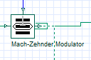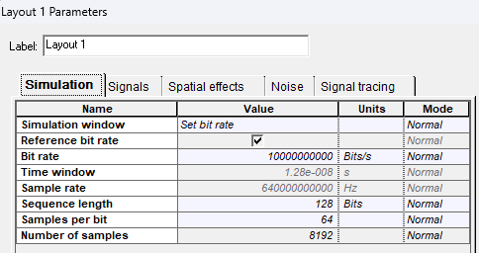
The MZM performs external intensity modulation by using the NRZ electrical signal to modulate the CW optical carrier. External modulation is preferred in many systems because it can reduce chirp and enable better performance than direct laser modulation.
Observed behavior:
- Optical output power switches between two intensity levels corresponding to bits 0 and 1.
- The spectrum broadens around the laser line due to modulation sidebands.
  - Transmission Channel
    - Optical Fiber
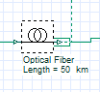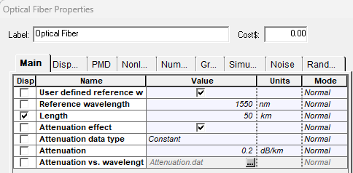
The optical fiber transports the modulated optical signal over 50 km. During propagation, the signal experiences:
- Attenuation (loss) reducing optical power
- Dispersion causing pulse broadening (ISI)
- Possible nonlinear effects (usually small at low power in basic simulations)
Configured parameter:
- Length = 50 km
Impact:
- Eye closure at receiver (depending on dispersion/loss settings)
- Reduced received amplitude and degraded BER/Q if impairments are significant
3.4 Receiver Section
3.4.1 Photodetector PIN
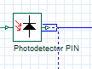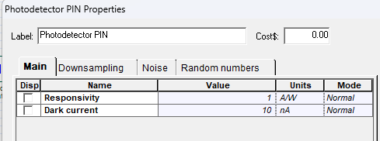
The PIN photodiode converts received optical power into electrical current proportional to optical intensity.
Observed output:
- Electrical NRZ-like waveform with noise and distortion depending on channel effects.

3.4.2 Low Pass Bessel Filter
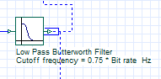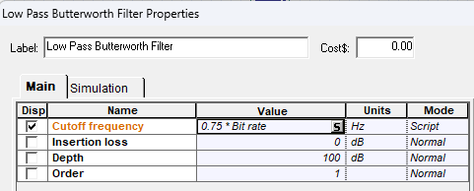
A Bessel low-pass filter is used because it has a maximally flat group delay. It removes high-frequency noise while preserving waveform shape.
Given in diagram:
- Cutoff frequency = 0.75 × bit rate
Role:
- Smooths noise and reduces bandwidth before decision/regeneration.
3.4.3 3R Regenerator
3R stands for: Re-amplify, Re-shape, Re-time
It restores logic levels and timing, improving the digital signal quality before BER measurement.
  - System Block Diagram
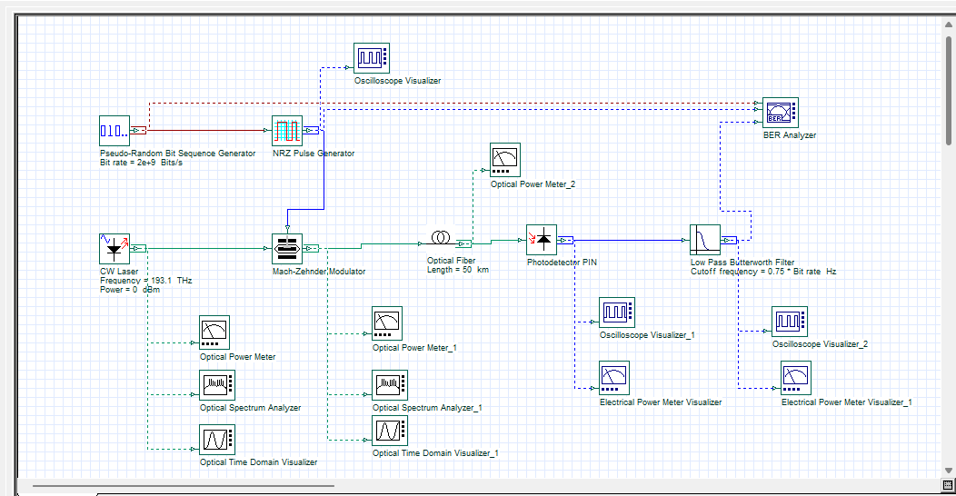
- PRBS and NRZ driving the MZM
- CW laser feeding the MZM
- 50 km optical fiber channel
- Receiver with PIN + Bessel LPF + 3R
- Multiple measurement instruments: oscilloscopes, OSA, power meters, and BER analyzer
- Results & Discussion
4.1 Signal Waveform Analysis (Tx & Rx)
4.1.1 Transmitted Signal (Tx)
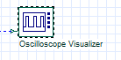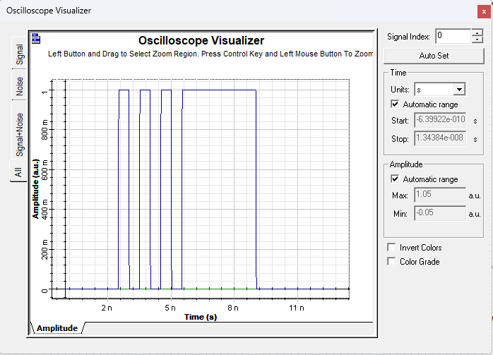
Observation:
- The electrical NRZ waveform from the pulse generator is clean with sharp transitions.
- After MZM, the optical intensity follows the NRZ pattern (higher optical level for ‘1’, lower for ‘0’).
- The Tx oscilloscope should show a well-defined NRZ pattern with minimal distortion.
Comment: A clean transmitter waveform implies that most performance degradation will come from the fiber and receiver noise/bandwidth limits.
4.1.2 Received Signal (Rx)
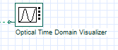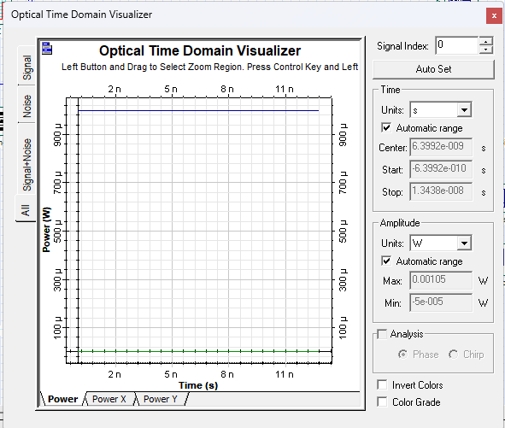
Observation :
Received electrical waveform after PIN shows reduced amplitude due to fiber attenuation.
- Some pulse spreading and inter-symbol interference (ISI) may appear after 50 km, depending on dispersion settings.
- After Bessel LPF, noise is reduced but edges may become slightly rounded.
- After 3R regeneration, waveform returns closer to ideal digital levels.
Comment: Any reduction in eye opening and increased jitter/noise directly impacts Q-factor and BER.
4.2 Power Measurements (Tx & Rx)
4.2.1 Transmitted Optical Power
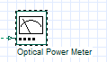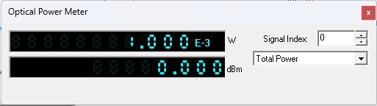
Record from Optical Power Meter near the transmitter output:
- Tx Optical Power (measured): 0.000 dBm
Observed trend:
- Power corresponds closely to the CW laser power minus modulator insertion loss.
4.2.2 Received Electrical Power
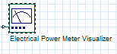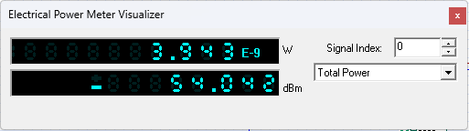
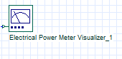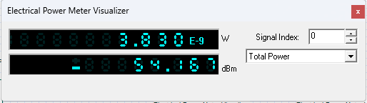
Record from Electrical Power Meter Visualizer before photodetection:
- Rx Electrical Power: 54.042 dBm
Record from Electrical Power Meter Visualizer after photodetection:
- Rx Electrical Power: 54.167dBm
Observed trend:
- Electrical power depends on received optical power and photodiode responsivity.
- Lower received optical power results in lower electrical signal amplitude.
4.3 Optical Spectrum Analyzer (OSA)
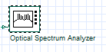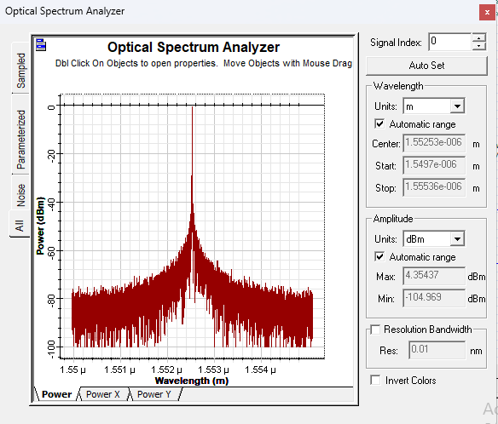
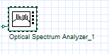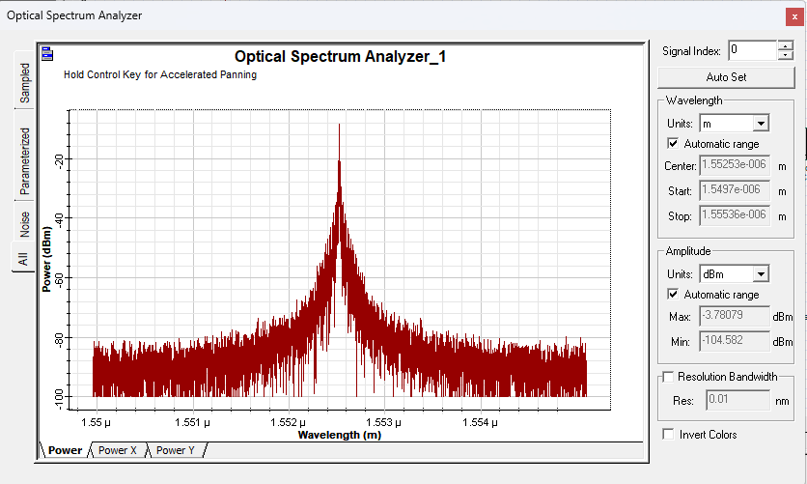
OSA results:
- A dominant carrier at 193.1 THz
- Sidebands around the carrier due to NRZ modulation
- Possible spectral broadening depending on modulator settings and extinction ratio
Discussion: NRZ intensity modulation produces a spectrum centered at the carrier frequency. Sideband structure indicates modulation and bandwidth. Excessive broadening may signal higher modulation depth or chirp.
4.4 Eye Diagram Analysis
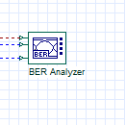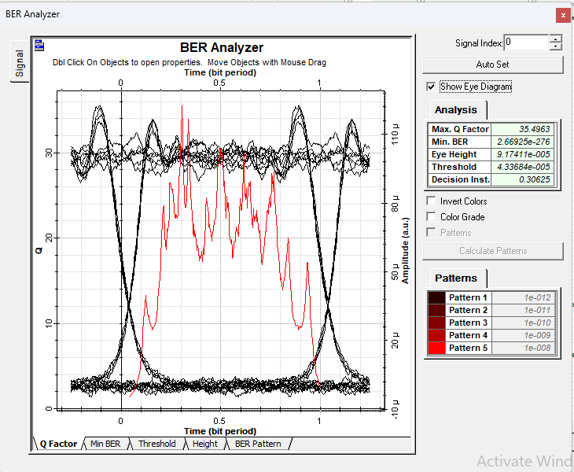
Observed behavior:
- Transmitter eye is typically wide open (high eye height, low jitter).
- Receiver eye may partially close due to fiber impairments and receiver filtering.
Key eye parameters:
- Eye height (signal margin)
- Eye width (timing margin)
- Crossing points and jitter
A more open eye corresponds to higher Q-factor and lower BER.
4.5 BER and Q Factor Analysis
From the above picture, we can see,
4.5.1 Bit Error Rate (BER)
From BER Analyzer:
- Min BER (measured): 2.66925e-276
- Decision threshold: 4.33684e-005
BER increases when received power decreases, dispersion increases, noise increases, or filtering is too aggressive.
4.5.2 Q Factor
Q-factor (measured): 35.4963
Higher Q indicates better separation between “1” and “0” distributions, leading to smaller BER.
- Conclusion
A complete NRZ optical communication link was successfully simulated using a PRBS source, NRZ pulse shaping, external modulation with an MZM, a 50 km optical fiber channel, and a direct-detection receiver (PIN + Bessel LPF + 3R). The transmitter produced a clean NRZ-modulated optical signal centered at 193.1 THz. After propagation through 50 km fiber, the received signal exhibited attenuation and potential pulse spreading, affecting the eye diagram opening. The receiver filtering and 3R regeneration improved signal quality and enabled BER and Q-factor evaluation. Overall, system performance depends strongly on received power, channel impairments, and receiver bandwidth selection.

